21ECP401L-MAJOR PROJECT

UWB-Based Indoor Localization and Tracking System

A PROJECT REPORT
Submitted by
KSHITIJ SRIVASTAVA [Reg No: RA2211004010344] AMBAR ROY [Reg No: RA2211004010332]
SHUBHAM RANJAN [Reg No: RA22114010346]
Under the guidance of

Dr. Subhashini J
(Associate Professor, Department of Electronics & Communication Engineering)
In partial fulfillment of the requirements for the Degree of
BACHELOR OF TECHNOLOGY
in


ELECTRONICS & COMMUNICATION ENGINEERING

DEPARTMENT OF ELECTRONICS AND COMMUNICATION ENGINEERING

COLLEGE OF ENGINEERING AND TECHNOLOGY

SRM INSTITUTE OF SCIENCE AND TECHNOLOGY

KATTANKULATHUR-603 203

MAY 2026
SRM INSTITUTE OF SCIENCE AND TECHNOLOGY
(Under Section 3 of UGC Act, 1956)
DEPARTMENT OF ELECTRONICS AND COMMUNICATION ENGINEERING

BONAFIDE CERTIFICATE

This is to certify that the project report titled “UWB-Based Indoor Localization and Tracking System”, submitted for 21ECP401L – Major Project, is a Bonafide work carried out by the following students:

KSHITIJ SRIVASTAVA(Reg. No.: RA2211004010344)
AMBAR ROY(Reg. No.: RA2211004010332)
SHUBHAM RANJAN(Reg. No.: RA2211004010346)
in partial fulfilment of the requirements for the award of the degree of B.Tech in Electronics and Communication Engineering. This work has been carried out under my supervision and guidance. To the best of my knowledge, the work reported herein has not been submitted, either in part or in full, for the award of any other degree or diploma by this or any other candidate.

Signature of the Supervisor  Dr. Subhashini J  Associate Professor  Department of Electronics and Communication Engineering  SRM Institute of Science and Technology  Kattankulathur- 603203 | Signature of HOD  Dr. M. SANGEETHA  Professor and Head  Department of Electronics and Communication Engineering SRM Institute of Science and Technology  Kattankulathur- 603203

This project report is submitted for the project university examination held on _________ May 2026, at Department of ECE, SRMIST, Kattankulathur.

Signature of the Internal Examiner Signature of the External Examiner
DECLARATION

We hereby declare that the Major Project entitled “UWB-Based Indoor Localization and Tracking System” to be submitted for the Degree of Bachelor of Technology is our original work as a team and the dissertation has not formed the basis of any degree, diploma, associateship or fellowship of similar other titles. It has not been submitted to any other University or institution for the award of any degree or diploma.

Place:

Date:

KSHITIJ SRIVASTAVA
[RA2211004010344]

AMBAR ROY
[RA2211004010332]

SHUBHAM RANJAN
[RA2211004010346]

ACKNOWLEDGEMENTS
We would like to express our deepest gratitude to the entire management of SRM Institute of Science and Technology for providing us with the necessary facilities for the completion of this project.

We wish to express our deep sense of gratitude and sincere thanks to our Professor and Head of the Department, Dr. M. Sangeetha, for her encouragement, timely help, and advice offered to us.

We are very grateful to our supervisor Dr. Subhashini J, Associate Professor, Department of Electronics and Communication Engineering, for providing invaluable guidance with inspiring dedication, untiring efforts, and tremendous enthusiasm in making this project successful and presentable.

We would like to express our sincere thanks to the project coordinator Dr. T. Saminathan and panel members Dr. S. Kayalvizhi and Dr. R. Kayalvizhi for their time and suggestions for the implementation of this project.

We also extend our gratitude and heartful thanks to all the teaching and non-teaching staff of the Electronics and Communications Engineering Department and to our parents and friends, who extended their kind cooperation using valuable suggestions and timely help during this project work.

KSHITIJ SRIVASTAVA
RA2211004010344

AMBAR ROY
RA2211004010332

SHUBHAM RANJAN
RA2211004010346

ABSTRACT

“ This project presents a UWB-based indoor localization and navigation system integrated with LoRa communication for large indoor environments such as departmental stores and warehouses. Since GPS is unreliable indoors, the system utilizes Ultra-Wideband (UWB) Time-of-Flight measurements to achieve high-accuracy position estimation of a mobile unit within the indoor space. LoRa communication is employed for long-range, low-power zone level data exchange between fixed anchor nodes and the mobile unit, enabling scalable deployment across large areas. A smart cart equipped with a microcontroller and an intelligent display provides real-time navigation and product location guidance to the user. The proposed system aims to deliver a low-cost, scalable, and accurate indoor navigation solution without dependence on external network infrastructure. This project primarily aligns with Sustainable Development Goal (SDG) 9 – Industry, Innovation, and Infrastructure. The proposed UWB-based indoor localization system integrated with LoRa communication promotes innovation in smart infrastructure by enabling accurate indoor navigation in environments where GPS is ineffective. By utilizing low-power and efficient wireless technologies, the system supports scalable and reliable infrastructure solutions for large indoor spaces such as retail stores, warehouses, and industrial facilities. The project contributes to improving operational efficiency, accessibility, and technological advancement, thereby supporting sustainable industrial development and intelligent infrastructure systems.



“ Additionally, the modular design allows easy expansion and adaptation to different indoor layouts. The system also minimizes resource wastage by optimizing movement and navigation within large indoor environments Sustainable Development Goals: The proposed project aligns with SDG 9 by developing an innovative hybrid UWB–LoRa indoor localization system that enhances smart infrastructure, improves operational efficiency, and enables scalable and energy-efficient indoor navigation.

TABLE OF CONTENTS

CHAPTER NO. | TITLE |  |  | PAGE NO.
 | ABSTRACT |  |  | i
 | LIST OF FIGURES |  |  | v
 | LIST OF TABLES |  |  | vi
 | ABBREVIATIONS |  |  | vii
 | LIST OF SYMBOLS |  |  | viii
1 | INTRODUCTION |  |  | 1
 | 1.1 | Challenges in Indoor Localization |  | 1
 | 1.2 | Need for Hybrid Localization Systems |  | 2
 | 1.3 | Shift Toward Transformer-Based Architectures |  | 3
 | 1.4 | Shift Toward Transformer-Based Architectures |  | 3
 | 1.5 | Advantages and Research Significance |  | 4
2 | LITERATURE REVIEW |  |  | 6
 | 2.1 | Overview |  | 6
 |  | 2.1.1 | Importance and Applications | 6
 |  | 2.1.2 | Challenges in Indoor Environments | 7
 | 2.2 | Wi-Fi and BLE-Based Indoor Localization |  | 7
 |  | 2.2.1 | Working Principle and Techniques | 8
 |  | 2.2.2 | CNN and RNN Architectures for social media Text | 9
 | 2.3 | UWB-Based High Accuracy Localization |  | 9
 |  | 2.3.1 | Working Mechanism | 9
 |  | 2.3.2 | Advantages and Limitations | 10
 | 2.4 | LoRa-Based Long-Range Communication Systems |  | 10
 |  | 2.4.1 | Working Principle | 10
 |  |  | Advantages and Limitations | 11
 |  |  | Hybrid Localization Systems and Research Gap | 11
 |  |  | Hybrid Approach and Benefits | 11
 |  |  | Research Gap and Proposed Solution | 12
3 | METHODOLOGY |  |  | 13
CHAPTER NO. | TITLE |  |  | PAGE NO.
 | 3.1 | System Overview |  | 13
 |  | 3.1.1 | Dual-Layer Localization Architecture | 13
 |  | 3.1.2 | System Components and Interaction | 14
 | 3.2 | LoRa-Based Zone-Level Localization |  | 14
 |  | 3.2.1 | RSSI-Based Distance Estimation | 15
 |  | 3.2.2 | Noise Modeling and Zone Detection | 16
 | 3.3 | UWB-Based Precise Localization |  | 16
 |  | 3.3.1 | Time-of-Flight (ToF) Measurement | 16
 |  | 3.3.2 | Trilateration for Position Estimation | 17
 | 3.4 | Signal Processing and Filtering |  | 17
 |  | 3.4.1 | Noise Characteristics in Indoor Signals | 17
 |  | 3.4.2 | Kalman Filtering for Accuracy Enhancement | 17
 | 3.5 | Hybrid Localization Strategy |  | 18
 |  | 3.5.1 | Threshold-Based Switching Mechanism | 18
 |  | 3.5.2 | Energy Efficiency and System Optimization | 19
 | 3.6 | Path Planning and Navigation |  | 20
 |  | 3.6.1 | Grid-Based Environment Modeling | 20
 |  | 3.6.2 | A* Algorithm for Optimal Routing | 21
 | 3.7 | System Implementation and Workflow |  | 21
 |  | 3.7.1 | End-to-End System Workflow | 22
 |  | 3.7.2 | Real-Time Processing and System Reliability | 22
4 | RESULTS AND DISCUSSIONS |  |  | 23
 | 4.1 | Indoor Environment Modeling and System Visualization |  | 23
 |  | 4.4.1 | System Parameters and Configuration | 24
 | 4.2 | Path Planning and Navigation Performance |  | 24
 |  | 4.2.1 | Localization Accuracy and Error Analysis | 25
 | 4.3 |  | LoRa-Based Distance Estimation and Noise Analysis | 26
 |  | 4.3.1 | Hybrid Localization System | 26
 | 4.4 | Effect of Kalman Filtering on Localization |  | 27
 |  | 4.4.1 | Contribution of Hybrid Localization (LoRa + UWB) | 27
CHAPTER NO. | TITLE |  |  | PAGE NO.
 |  | 4.4.2 | Impact of Signal Processing and Filtering | 28
 |  | 4.4.3 | Effectiveness of Zone-Based Navigation | 28
 | 4.5 | System Output and User Interface Analysis |  | 29
 | 4.6 | Performance Evaluation |  | 29
 |  | 4.6.1 | Distance vs Localization Accuracy | 30
 |  | 4.6.2 | LoRa Communication Performance | 30
 |  | 4.6.3 | Path Deviation Analysis | 31
 |  | 4.6.4 | System Response Time | 31
 | 4.7 | Comparison with Existing Methods |  | 31
 |  | 4.7.1 | GPS-Based Systems | 31
 |  | 4.7.2 | Wi-Fi RSSI-Based Localization | 32
 |  | 4.7.3 | Bluetooth Low Energy (BLE) Systems | 32
 | 4.8 | Realistic Constraints (System Latency, Cost, and Data Handling) |  | 32
5 | CONCLUSION AND FUTURE WORK |  |  | 35
 | 5.1 | Conclusion |  | 35
 | 5.2 | Future work |  | 35
 | REFERENCES |  |  | 37
 | PUBLICATION DETAILS |  |  | 39

LIST OF FIGURES

FIGURE NO. | TITLE | PAGE NO.
3.1 | RSSI-based distance estimation under noisy indoor conditions | 15
3.2 | Noise reduction using Kalman filtering | 17
3.3 | Hybrid LoRa–UWB switching mechanism | 19
3.4 | Optimal path generation using A* algorithm | 20
3.5 | lock Diagram of Smart Cart Navigation System Using LoRa and UWB | 21
4.1 | Hardware Prototype | 23
4.2 | LoRa Distance Monitoring GUI | 24
4.3 | Meter Level Positioning | 26
4.4 | Zone-Based Navigation | 28
4.5 | User Interface | 29

LIST OF TABLES

FIGURE NO. | TITLE | PAGE NO.
4.1 | System Configuration Parameters | 24
4.2 | Comparison of Integrating Multiple Technologies | 27
4.3 | Experimental Results and Performance Analysis | 30

ABBREVIATIONS
Abbreviation | Meaning
UWB | - Ultra-Wideband
LoRa | - Long Range Communication
RSSI | - Received Signal Strength Indicator
ToF | - Time of Flight
TDoA | - Time Difference of Arrival
AoA | - Angle of Arrival
GPS | - Global Positioning System
IoT | - Internet of Things
LPWAN | - Low Power Wide Area Network
MCU | - Microcontroller Unit
ESP32 | - Microcontroller with Wi-Fi and Bluetooth
A* | - A-Star Path Planning Algorithm
NLOS | - Non-Line of Sight
LOS | - Line of Sight
BLE | - Bluetooth Low Energy
RFID | - Radio Frequency Identification
GUI | - Graphical User Interface
SDG | - Sustainable Development Goals
SPI | - Serial Peripheral Interface
UART | - Universal Asynchronous Receiver Transmitter
ADC | - Analog to Digital Converter
Kalman Filter | - Recursive filtering algorithm for estimation
Trilateration | - Position estimation using distances
Path Loss | - Signal attenuation over distance
Anchor Node | - Fixed reference node in localization
Tag | - Mobile device being tracked
Grid Model | - Discrete environment representation
Smart Cart | - Mobile navigation unit

LIST OF SYMBOLS
Symbol | Meaning
D | - Distance between transmitter and receiver
d₀ | - Reference distance
RSSI(d) | - Received signal strength at distance d
RSSI(d₀) | - Reference RSSI value
N | - Path loss exponent
Xσ | - Gaussian noise component
C | - Speed of light
T | - Time of Flight
(x, y) | - Estimated position coordinates
(x₁, y₁), (x₂, y₂), (x₃, y₃) | - Anchor node coordinates
d₁, d₂, d₃ | - Distances from anchors
x̂ₖ | - Estimated state at step k
x̂ₖ⁻ | - Predicted state
A | - State transition matrix
B | - Control input matrix
uₖ | - Control input
Kₖ | - Kalman gain
zₖ | - Measurement value
H | - Measurement matrix
f(n) | - Total cost function in A*
g(n) | - Actual cost from start node
h(n) | - Heuristic estimated cost
Error | - Localization error
Θ | - Angle of arrival
Δt | - Time difference
N | - Number of anchor nodes
Z | - Zone identifier
d_threshold | - Switching threshold distance

CHAPTER 1
INTRODUCTION

“ Accurate indoor positioning is challenging as systems like GPS become unreliable due to signal attenuation and multipath effects. In large indoor environments such as malls and warehouses, users often face difficulty in locating items and navigating efficiently, leading to increased time and effort. This report presents a hybrid indoor localization system that combines Ultra-Wideband (UWB) and LoRa technologies to achieve both wide coverage and high accuracy. LoRa enables long-range communication for zone-level detection, while UWB provides precise positioning using Time-of-Flight measurements.

Challenges in Indoor Localization

“ Accurate positioning in indoor environments remains a significant technical challenge due to the complex nature of signal propagation. Unlike outdoor environments where GPS signals are directly received from satellites, indoor environments introduce multiple obstacles such as walls, ceilings, metallic structures, and moving objects. These obstacles cause signal attenuation, reflection, diffraction, and multipath propagation, which severely degrade positioning accuracy. In addition, indoor environments are highly dynamic. As a result, systems relying on signal strength measurements often produce fluctuating and unreliable results.

Need for Hybrid Localization Systems

“ Traditional indoor localization techniques primarily rely on signal strength-based methods such as Wi-Fi fingerprinting, Bluetooth Low Energy (BLE), and RFID systems. Wi-Fi fingerprinting involves creating a database of signal strength values at different locations and matching real-time measurements with stored data. However, this approach requires extensive calibration and frequent updates due to environmental changes. Similarly, BLE-based systems use beacon signals to estimate proximity, but their accuracy is limited and affected by interference and signal fluctuations.

Shift Toward Transformer-Based Architectures

“ Despite the advantages of modern technologies, no single system can fully address the requirements of indoor localization. UWB offers high accuracy but is limited by its short communication range and higher infrastructure requirements. Deploying UWB across large environments can be costly and energy-intensive.On the other hand, LoRa provides excellent coverage and low power consumption but lacks the precision required for accurate positioning. RSSI-based distance estimation used in LoRa systems is often affected by noise and environmental factors, leading to significant errors.

Proposed UWB–LoRa Hybrid Framework

“ To address the challenges of indoor localization, this project proposes a hybrid framework that integrates LoRa and UWB technologies in a dual-layer architecture. At the first level, LoRa communication is used for zone-level localization. The system estimates the distance between the mobile unit and multiple zone nodes using RSSI-based path loss models. Based on these estimates, the system identifies the approximate location or zone of the user within the environment. Once the user approaches the target zone within a predefined threshold distance (e.g., 30 meters), the system activates UWB-based localization. UWB uses Time-of-Flight measurements to calculate precise distances between the mobile unit and anchor nodes. These distances are then used in trilateration algorithms to determine the exact position.

“ To improve reliability, signal processing techniques such as Kalman filtering are applied to reduce noise and stabilize position estimates.

Advantages and Research Significance

“ The proposed hybrid localization system offers several key advantages over conventional methods. First, it provides a balance between coverage and accuracy by combining long-range and high-precision technologies. This makes it suitable for large indoor environments where both scalability and precision are required. Second, the system is energy-efficient due to its selective activation mechanism. By using UWB only when necessary, the system reduces power consumption and improves overall efficiency.

“ Overall, the system represents a practical and scalable approach to indoor localization, addressing key challenges while opening opportunities for future advancements in intelligent navigation systems. The system also enhances user interaction by providing intuitive navigation guidance through visual interfaces. This improves user experience, especially for first-time visitors in large indoor environments.

CHAPTER 2
LITERATURE REVIEW

Overview

“ Indoor localization is a key enabling technology for next-generation smart environments, where real-time positioning information is essential for navigation, monitoring, and automation. With the rapid growth of Internet of Things (IoT) systems and smart infrastructure, the demand for accurate and scalable indoor positioning solutions has increased significantly. Unlike outdoor localization, which relies on satellite-based systems such as GPS, indoor environments require alternative approaches due to signal attenuation, obstruction, and multipath effects [1].
One of the major challenges in indoor localization arises from the variability of signal behavior across different environments.

“ Furthermore, different applications impose varying requirements on localization accuracy. For instance, retail navigation systems may require meter-level accuracy for zone detection, whereas industrial automation and asset tracking demand centimeter-level precision. Consequently, research has shifted toward adaptive and hybrid systems that can provide both scalability and precision depending on the operational context [6].

Importance and Applications

“ Indoor localization plays a crucial role in a wide range of applications, including smart retail navigation, warehouse management, healthcare monitoring, and industrial automation. In retail environments, it enables customers to locate products efficiently, reducing search time and improving user experience.

“ Indoor localization plays a crucial role in a wide range of applications, including smart retail navigation, warehouse management, healthcare monitoring, and industrial automation. In retail environments, it enables customers to locate products efficiently, reducing search time and improving user experience. In warehouses, it supports inventory tracking and logistics optimization, while in healthcare systems, it facilitates patient monitoring and equipment tracking.

Challenges in Indoor Environments

“ Multipath propagation is another critical issue, where signals take multiple paths due to reflections from surfaces. This results in fluctuations in signal strength and timing measurements, making it difficult to obtain consistent localization results. Additionally, environmental dynamics such as human movement and layout changes further affect signal behavior. These challenges highlight the need for advanced localization techniques that incorporate robust signal processing, adaptive algorithms, and hybrid communication strategies to achieve stable and accurate positioning [1], [9]

Wi-Fi and BLE-Based Indoor Localization

“ Wi-Fi and Bluetooth Low Energy (BLE) technologies are among the most widely used solutions for indoor localization due to their availability and ease of deployment. These systems primarily rely on Received Signal Strength Indicator (RSSI) measurements to estimate the distance between a device and access points or beacon nodes. RSSI-based methods suffer from significant limitations due to their sensitivity to environmental conditions.

Working Principle and Techniques

“ Initial rumor detection systems used handcrafted linguistic features such as n-grams, sentiment polarity, modality markers (e.g., “might”, “reportedly”), and punctuation patterns, combined with classical classifiers like SVM and logistic regression. Researchers also engineered credibility indicators from user profiles and source domains to approximate trustworthiness. While effective on curated datasets, these pipelines required heavy feature tuning and were sensitive to topic drift and language variation. They also struggled to capture contextual meaning in short, informal posts. Studies consistently reported that engineered features can overfit platform-specific quirks, limiting transferability across events and communities [2], [6].

“ Despite limitations, feature-based methods established important baselines and introduced evaluation settings for early-warning and incremental verification. Some approaches modeled conversational threads to identify skepticism, corrections, or questioning language, treating replies as evidence signals rather than noise. Others incorporated temporal features to capture how rumors change wording as they spread.

UWB-Based High Accuracy Localization

“ Ultra-Wideband (UWB) technology enables precise indoor positioning using time-based measurements instead of signal strength, making it highly suitable for high-accuracy applications [5].

Working Mechanism

“ UWB systems determine distance by measuring the Time-of-Flight (ToF) of signals between a transmitter and receiver. Since UWB transmits extremely short pulses over a wide frequency spectrum, it enables precise measurement of signal travel time. This allows accurate estimation of distance even in environments with significant multipath propagation. In addition to ToF, techniques such as Time Difference of Arrival (TDoA) and Angle of Arrival (AoA) are used to enhance positioning accuracy. This improves trajectory estimation and ensures consistent positioning over time [8], [12].

Advantages and Limitations
“ UWB offers several advantages, including high accuracy, strong resistance to multipath interference, and reliable performance in indoor environments. Unlike RSSI-based methods, UWB does not rely on signal strength, making it less sensitive to environmental variations.However, UWB has certain limitations. The communication range is relatively short, requiring a higher number of anchor nodes to cover large areas. This increases infrastructure cost and deployment complexity [11].

LoRa-Based Long-Range Communication Systems

“ LoRa technology is widely used for long-range communication with low power consumption, making it suitable for large-scale indoor localization applications [7].

Working Principle

“ LoRa operates using a spread spectrum modulation technique, which allows signals to travel long distances while maintaining low energy consumption. In indoor localization systems, LoRa is primarily used for coarse positioning by estimating distance based on RSSI values. The received signal strength is converted into distance using path loss models, such as the log-distance path loss model. Although this approach does not provide high precision, it is effective for determining the general location or zone of a device within a large environment. LoRa communication also enables data exchange between nodes over long distances, allowing centralized or distributed systems to operate efficiently. This capability is particularly useful in environments where multiple users or devices need to be tracked simultaneously [15].

Advantages and Limitations

“ LoRa offers several advantages, including long communication range, low power consumption, and cost-effective deployment. It reduces the need for dense infrastructure, making it suitable for large indoor environments. Another advantage is its ability to maintain communication even in challenging environments with obstacles and interference. This ensures reliable connectivity across large areas. However, LoRa-based localization suffers from low accuracy due to fluctuations in RSSI measurements. Environmental factors such as multipath propagation, interference, and signal fading introduce errors in distance estimation.
“
“ Additionally, LoRa cannot provide fine-grained localization required for applications such as rack-level navigation. Therefore, it is primarily used for coarse localization and is often combined with high-accuracy technologies like UWB to improve overall system performance [15].

Hybrid Localization Systems and Research Gap

“ Hybrid localization systems combine multiple technologies to achieve both wide coverage and high accuracy, addressing the limitations of individual approaches [6].

Hybrid Approach and Benefits

“ Hybrid systems use a layered approach where different technologies are used for different levels of localization. For example, long-range communication systems such as LoRa are used for zone-level detection, while high-precision technologies such as UWB are used for detailed positioning within a specific area. This approach improves system efficiency by reducing the need for continuous high-precision localization. Instead, accurate localization is activated only when required, which helps in reducing power consumption and computational load.

Research Gap and Proposed Solution

“ The proposed project addresses these gaps by implementing a hybrid UWB–LoRa framework that combines long-range communication with high-precision localization. A threshold-based mechanism is used to activate UWB only when the device is within a certain distance, improving energy efficiency. Furthermore, signal processing techniques such as Kalman filtering are applied to reduce noise and enhance accuracy. This approach provides a scalable, reliable, and energy-efficient solution for indoor localization in large environments.

\

CHAPTER 3
METHODOLOGY

System Overview

“ The proposed indoor localization system is designed as a hybrid framework that integrates LoRa and Ultra-Wideband (UWB) technologies to achieve a balance between wide-area coverage and high-precision positioning. The motivation behind adopting a hybrid approach arises from the inherent limitations of individual localization technologies. While LoRa offers long-range communication with minimal power consumption, it lacks the precision required for fine-grained localization.

“ The indoor environment is represented as a structured grid-based layout, where the entire space is divided into multiple zones. Each zone is associated with predefined anchor nodes and mapped product locations, enabling a direct correspondence between physical space and digital representation.

Dual-Layer Localization Architecture

“ The system employs a dual-layer localization architecture to optimize both performance and efficiency. At the first level, LoRa-based communication is used to perform macro-level localization by estimating the distance between the smart cart and multiple zone nodes using RSSI measurements. As the cart approaches the target zone, the system transitions to the second level, where UWB-based localization is activated.

“ By combining coarse and fine localization techniques, the system achieves a balance between scalability and accuracy, making it suitable for real-world deployment in complex indoor environments [11].

System Components and Interaction

“ The proposed system consists of two primary components: zone nodes and the smart cart unit, which interact continuously to enable localization and navigation. Each zone node is equipped with a microcontroller, a LoRa communication module, and a UWB anchor. These nodes are strategically deployed across the indoor environment to ensure adequate coverage and accurate positioning. In addition to communication functionality, zone nodes store information related to product locations and environmental mapping.

“ The smart cart unit is designed as a mobile embedded system that integrates a microcontroller (such as ESP32), a LoRa transceiver, a UWB tag, and a display interface for user interaction. When a user initiates a product search, the cart transmits a query via LoRa communication to all zone nodes.

LoRa-Based Zone-Level Localization

RSSI-Based Distance Estimation

“ The system utilizes RSSI measurements to estimate the distance between the smart cart and zone nodes. This improves the stability and reliability of distance estimates, enabling accurate identification of the nearest zone [7], [15]. The relationship between RSSI and distance is modeled using the log-distance path loss model:

𝒅
𝑹𝑺𝑺𝑰(𝒅) = 𝑹𝑺𝑺𝑰(𝒅_{𝟎}) − 𝟏𝟎𝒏𝐥𝐨𝐠 _{𝟏𝟎} (
𝒅
𝟎
) + 𝑿_{𝝈}

Where:
- 𝑅𝑆𝑆𝐼(𝑑) = received signal strength at distance 𝑑
- 𝑅𝑆𝑆𝐼(𝑑₀) = reference signal strength
- 𝑛= path loss exponent
- 𝑋_{𝜎}= Gaussian noise
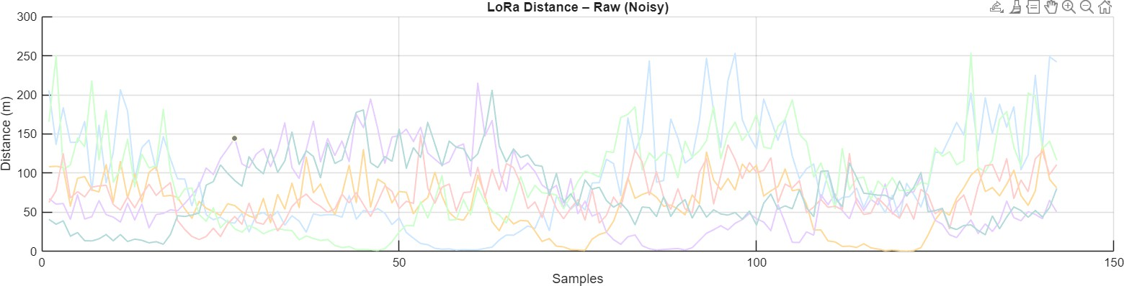

Fig 3.1: RSSI-based distance estimation under noisy indoor conditions

Noise Modeling and Zone Detection

“ Indoor wireless signals are subject to significant noise due to multipath propagation, interference, and environmental dynamics. Multipath propagation causes signals to arrive at the receiver through multiple paths, resulting in fluctuations in signal strength. Similarly, interference from other devices can introduce additional variability in measurements.This approach ensures robust localization even in dynamic environments where signal conditions may vary significantly [9].

UWB-Based Precise Localization
“
“ UWB technology is used to provide high-precision localization within the selected zone, enabling accurate positioning at the rack level.

Time-of-Flight (ToF) Measurement

“ UWB systems determine distance by measuring the time taken for a signal to travel between devices. Since electromagnetic signals propagate at the speed of light, the distance can be calculated using the measured time delay. As a result, UWB can achieve centimeter-level accuracy, making it suitable for applications that require precise localization, such as guiding users to specific product locations [10].

d=c×t
Where:
      - 𝒅= distance
      - 𝒄= speed of light
      - 𝒕= time-of-flight

Trilateration for Position Estimation
“ The exact position of the smart cart is determined using trilateration, which involves calculating the intersection point of multiple distance measurements from anchor nodes. Proper placement of anchors ensures better geometric diversity, reducing errors in position estimation. This enables accurate localization within the target zone and ensures efficient navigation.

(𝒙 − 𝒙_{𝟐})^{𝟐} + (𝒚 − 𝒚_{𝟐})^{𝟐} = 𝒅^{𝟐}
𝟐
(𝒙 − 𝒙_{𝟑})^{𝟐} + (𝒚 − 𝒚_{𝟑})^{𝟐} = 𝒅^{𝟐}
𝟑

Signal Processing and Filtering

Noise Characteristics in Indoor Signals

“ Indoor signals are affected by various sources of noise, including reflections, interference, and environmental changes. These factors introduce variability in measurements, making localization results unstable. Understanding these noise characteristics is crucial for designing effective filtering techniques that can improve system performance.

Kalman Filtering for Accuracy Enhancement

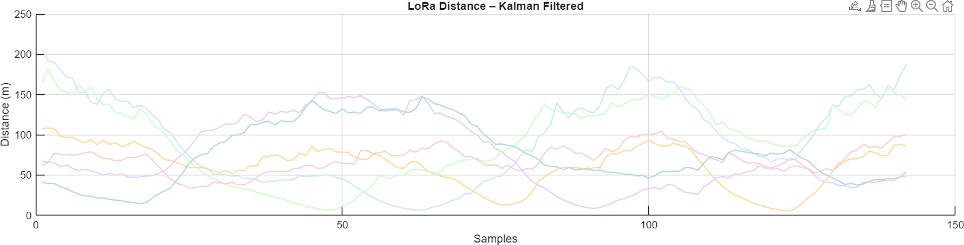
“ To reduce noise and improve stability, the system employs a Kalman filter. This algorithm combines predicted and measured values to produce a more accurate estimate of position. The Kalman filter operates iteratively, refining the position estimate over time. This results in smoother trajectories and more reliable localization results, particularly in dynamic environments [8], [12].

Fig 3.2: Noise reduction using Kalman filtering

Hybrid Localization Strategy
“ The hybrid localization strategy forms the core of the proposed system, enabling the seamless integration of LoRa and UWB technologies to achieve both scalability and precision. By reducing the dependency on continuous high-precision localization, the system achieves a significant improvement in energy efficiency and computational performance, which are critical factors for real-world deployment in large indoor environments [6].

If 𝒅 ≤ 𝒅_{𝒕𝒉𝒓𝒆𝒔𝒉𝒐𝒍𝒅} → Activate UWB

Energy Efficiency and System Optimization

“ Energy efficiency is a critical consideration in the design of the proposed system, particularly because the smart cart operates as a mobile, battery-powered device. Continuous operation of high-precision localization systems such as UWB can lead to rapid energy depletion, making it impractical for long-term usage.

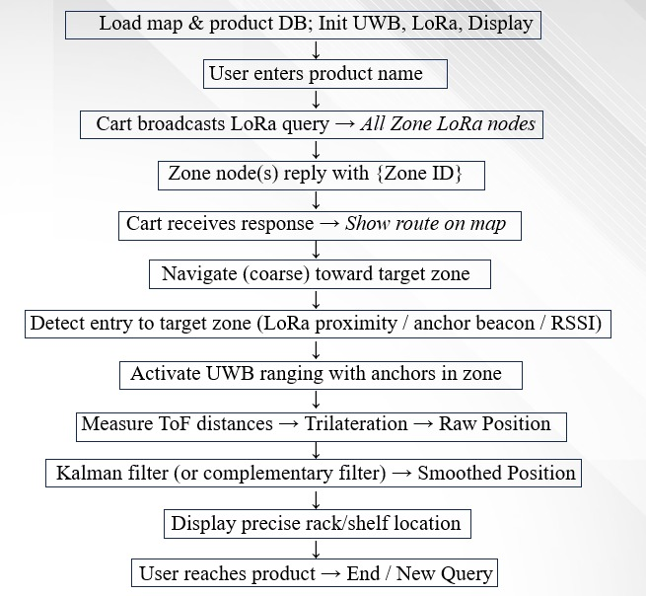

Fig 3.3: Hybrid LoRa–UWB switching mechanism

Path Planning and Navigation

“ Efficient navigation is a critical component of the proposed system, as it directly influences user experience and system usability. The path planning module is designed to compute optimal routes from the current position of the smart cart to the desired product location, taking into account environmental constraints and movement restrictions.

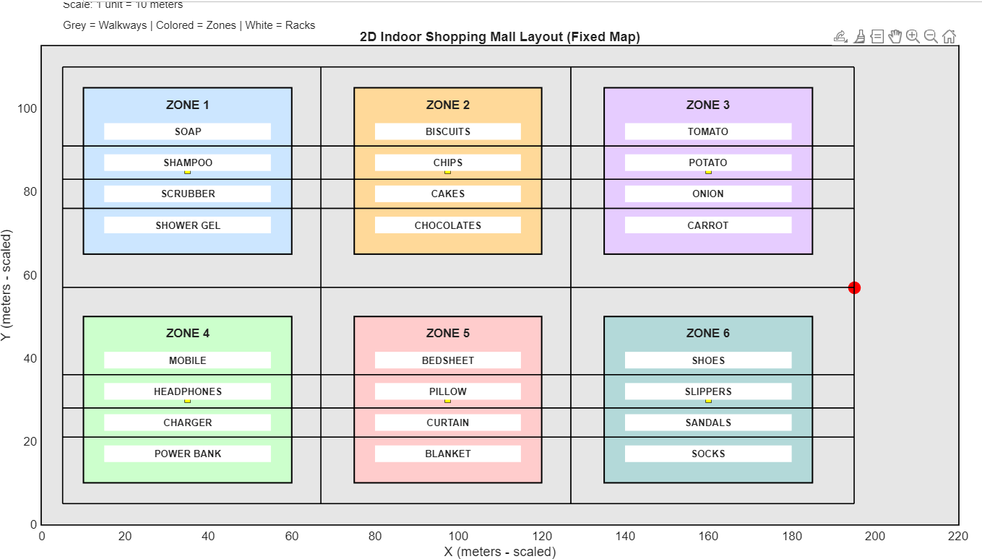
Fig 3.4: Optimal path generation using A algorithm*

A* Algorithm for Optimal Routing

“ The A* algorithm is employed to compute the shortest and most efficient path between the current location of the smart cart and the target destination. This algorithm is widely used in pathfinding applications due to its ability to combine optimality with computational efficiency.
The A* algorithm operates by evaluating nodes based on a cost function defined as:

𝒇(𝒏) = 𝒈(𝒏) + 𝒉(𝒏)

“ where 𝒈(𝒏) represents the actual cost from the start node to the current node, and 𝒉(𝒏) represents the estimated cost from the current node to the target.

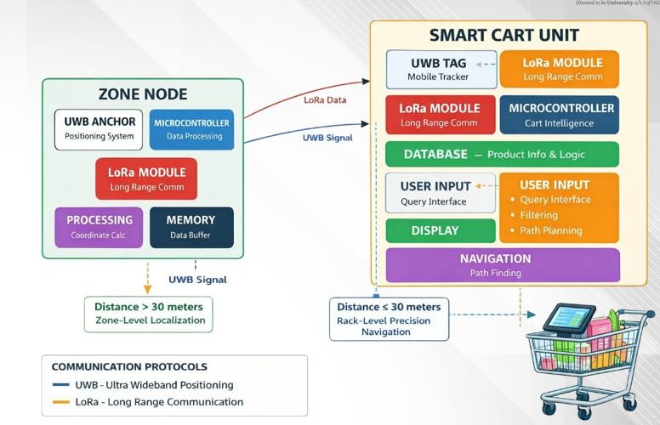
System Implementation and Workflow

Fig.3.5: Block Diagram of Smart Cart Navigation System Using LoRa and UWB

End-to-End System Workflow

“ The complete operation of the system follows a structured workflow that ensures smooth interaction between different components. Initially, the user inputs the desired product through the smart cart interface. This input is processed by the microcontroller, which initiates a LoRa-based query to all zone nodes.

Real-Time Processing and System Reliability

“ Real-time operation is a critical requirement for indoor localization systems, as delays in processing can affect navigation accuracy and user experience. The proposed system is designed to minimize latency by optimizing communication protocols and computational processes. LoRa communication is used for periodic updates, ensuring continuous tracking of the cart’s position without excessive data transmission. UWB localization is triggered only when necessary, reducing processing overhead.

CHAPTER 4
RESULTS AND DISCUSSION

Indoor Environment Modeling and System Visualization

“ The performance evaluation of the proposed hybrid UWB–LoRa indoor localization system is conducted using a structured simulation environment that closely replicates a real-world shopping mall scenario. The environment is modeled as a two-dimensional grid-based layout, where different spatial elements such as zones, racks, and walkable paths are clearly defined.

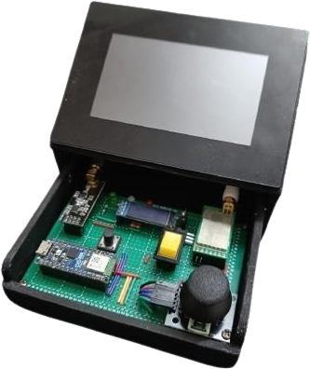
“ The environment is divided into multiple zones, each corresponding to a specific category of products such as groceries, snacks, household items, and kitchen essentials. This zoning mechanism plays a crucial role in enabling hierarchical localization, where LoRa is used for identifying the broader zone and UWB is activated for precise localization within that zone.

Fig 4.1 Hardware prototype

System Parameters and Configuration

“ The performance of the hybrid localization system is highly dependent on the selection of system parameters. Parameters such as the path loss exponent, threshold distance, and number of anchor nodes play a crucial role in determining localization accuracy and system efficiency. These parameters are optimized through experimental calibration to achieve the best possible performance under given environmental conditions.

Table 4.1: System Configuration Parameters

Parameter | Value | Description
LoRa Frequency | 868/915 MHz | Long-range communication
UWB Frequency | 3.1–10.6 GHz | High-precision localization
Threshold Distance | 30 m | Switching point
Path Loss Exponent (n) | 2–4 | Indoor propagation factor
No. of UWB Anchors | 3–5 | Trilateration nodes
Grid Resolution | Variable | Navigation accuracy

Localization Accuracy and Error Analysis

“ The localization accuracy of the proposed system is evaluated by comparing the estimated position of the smart cart with its actual position. This comparison provides insight into the effectiveness of both LoRa-based and UWB-based localization techniques. The positioning error is calculated using the Euclidean distance formula:
𝑬𝒓𝒓𝒐𝒓 = √(𝒙𝒂𝒄𝒕𝒖𝒂𝒍 − 𝒙𝒆𝒔𝒕)𝟐 + (𝒚𝒂𝒄𝒕𝒖𝒂𝒍 − 𝒚𝒆𝒔𝒕)𝟐

This equation quantifies the deviation between actual and estimated coordinates, providing a standard metric for evaluating localization performance.

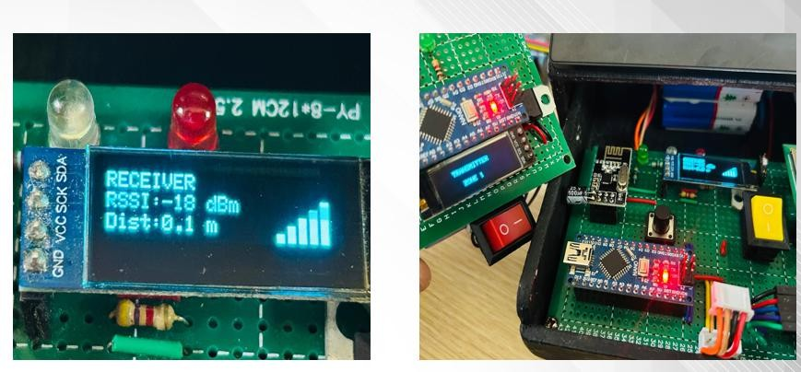
LoRa-Based Distance Estimation and Noise Analysis

Fig 4.3: Meter Level Positioning

The LoRa-based localization component is evaluated by analyzing RSSI-based distance estimation under realistic indoor conditions. The system uses the log-distance path loss model to estimate distances between the smart cart and zone nodes:
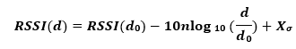
where 𝒏 represents the path loss exponent and 𝑿_{𝝈}represents Gaussian noise. The estimated distance is given by:
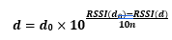

The results show that RSSI-based distance estimation is significantly affected by environmental factors such as multipath propagation, shadowing, and interference.

Hybrid Localization System

The hybrid localization system is evaluated by comparing its performance with standalone LoRa and UWB systems. This comparison highlights the advantages of integrating multiple technologies.
Method | Accuracy | Coverage | Power Consumption
LoRa | Low | High | Low
UWB | Very High | Low | Medium
Hybrid | High | High | Optimized

Table 4.2 Comparison of Integrating Multiple Technologies

The results demonstrate that the hybrid system achieves superior performance by combining the strengths of both technologies.

Effect of Kalman Filtering on Localization
Noise is a major challenge in indoor localization systems, particularly for RSSI-based measurements. To address this issue, the proposed system incorporates Kalman filtering to improve accuracy and stability. The results show that Kalman filtering significantly reduces fluctuations in localization data. The filtered output exhibits smoother trajectories and lower error compared to raw measurements, demonstrating the effectiveness of the approach.

Contribution of Hybrid Localization (LoRa + UWB)

To evaluate the effectiveness of the proposed hybrid localization system, a comparative analysis is performed by isolating individual components and measuring their impact on overall performance. Initially, the system is tested using only LoRa-based localization, which relies on RSSI measurements for distance estimation.[3] While this approach provides reliable zone-level detection, it exhibits significant positioning error due to environmental noise and signal attenuation. The accuracy in such cases is limited to a few meters, which is insufficient for precise navigation.[1] A second configuration utilizes only UWB-based localization, which provides highly accurate positioning using Time-of-Flight measurements. However, this approach suffers from limited coverage and increased infrastructure requirements, making it less suitable for large indoor environments.[2]

Effectiveness of Zone-Based Navigation

The zoning strategy plays a crucial role in improving system efficiency by reducing the complexity of localization and navigation. By dividing the indoor environment into predefined zones, the system can limit the search space and focus on relevant regions. The effectiveness of this approach is evaluated by comparing navigation performance with and without zoning. In contrast, the zone-based approach enables faster decision-making by narrowing down the search area.[6]
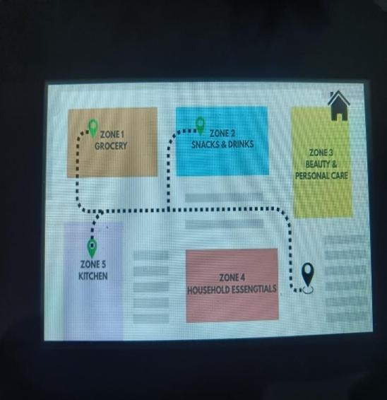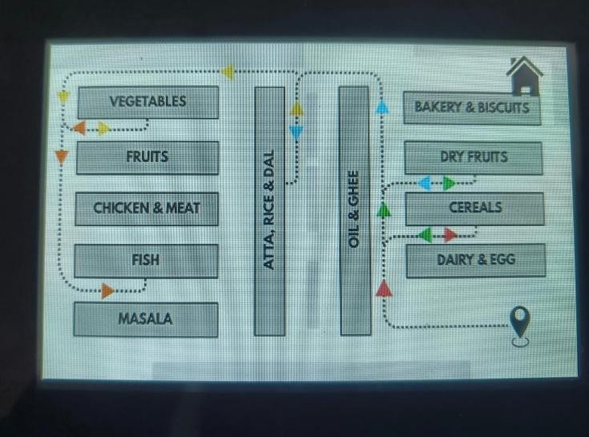

Fig 4.4: Zone-Based Navigation

System Output and User Interface Analysis
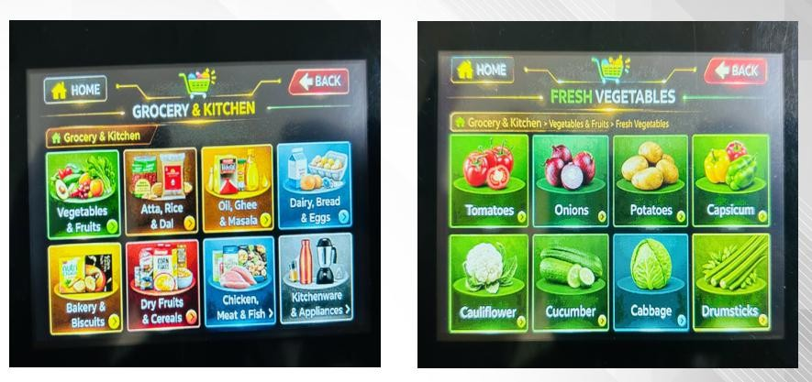

Fig 4.5: User Interface

The system output is visualized through an interactive user interface integrated into the smart cart. The interface allows users to select products, view navigation paths, and receive real-time guidance. The interface is designed to be intuitive and user-friendly, ensuring accessibility for a wide range of users.

Performance Evaluation

The performance evaluation of the proposed smart indoor navigation system was carried out to analyze its effectiveness in terms of localization accuracy, communication reliability, navigation efficiency, and computational response.

Test Case | Distance Covered (m) | UWB Position Error (m) | LoRa Packet Success (%) | Path Deviation (m) | Total Time (ms)
Test 1 | 120 m | 0.18 m | 98% | 0.25 m | 310 ms
Test 2 | 210 m | 0.32 m | 95% | 0.48 m | 420 ms
Test 3 | 340 m | 0.58 m | 91% | 0.85 m | 610 ms
Test 4 | 480 m | 0.42 m | 93% | 0.62 m | 780 ms
Test 5 | 500 m | 0.75 m | 88% | 1.20 m
Table 4.3: Experimental Results and Performance Analysis

Distance vs Localization Accuracy

The system was tested over distances ranging from 120 meters to 500 meters. It is observed that the UWB positioning error increases gradually from 0.18 m in Test 1 to 0.75 m in Test 5. This increase is expected due to accumulated measurement uncertainties and environmental interference over longer distances. However, the system consistently maintains sub-meter accuracy, which is highly acceptable for indoor navigation applications such as shopping malls. This demonstrates the robustness of the UWB-based fine localization mechanism within the hybrid framework.

Path Deviation Analysis

Path deviation measures how closely the actual navigation path follows the planned shortest route. The results show a gradual increase from 0.25 m to 1.20 m as the distance increases. This deviation is influenced by factors such as noise in distance estimation, filtering limitations, and discrete grid-based movement constraints. Even at higher distances, the deviation remains minimal and within acceptable limits, confirming that the routing algorithm effectively guides the cart along near-optimal paths.

Comparison with Existing Methods

Indoor localization and navigation have been extensively studied using a variety of technologies, each with its own advantages and limitations. The proposed smart indoor navigation system is compared with commonly used approaches such as GPS, Wi-Fi RSSI, Bluetooth Low Energy (BLE) and RFID based systems to evaluate its performance in terms of accuracy, reliability, scalability, cost, and practical feasibility.

GPS-Based Systems
Global Positioning System (GPS) is widely used for outdoor navigation; however, it is not suitable for indoor environments due to signal attenuation caused by walls, ceilings, and structural obstacles. GPS signals are significantly weakened indoors, resulting in poor accuracy (greater than
5 meters) and unreliable positioning. Therefore, GPS cannot be used for applications requiring fine-grained indoor localization, such as rack-level navigation in shopping malls.

Bluetooth Low Energy (BLE) Systems

BLE beacon-based systems are commonly used for proximity detection and indoor positioning. While BLE offers low power consumption and ease of deployment, it suffers from similar limitations as Wi-Fi, including signal instability and limited accuracy. The typical accuracy of BLE-based systems ranges from 1 to 3 meters, which may be acceptable for general location awareness but not for accurate rack-level navigation.

Realistic Constraints (System Latency, Cost, and Data Handling)

The deployment of the proposed hybrid UWB–LoRa indoor localization system in real-world environments involves several practical constraints that must be carefully considered to ensure reliable and efficient operation. While the system demonstrates strong performance under controlled conditions, factors such as system latency, infrastructure cost, and data handling significantly influence its feasibility in large-scale implementations. Addressing these constraints is essential for transitioning the system from a research prototype to a deployable solution in commercial and industrial environments.

Environmental factors further complicate system deployment. Indoor environments are dynamic, with varying levels of interference caused by obstacles, electronic devices, and human movement. While signal processing techniques such as Kalman filtering help mitigate these effects, complete elimination of environmental influence is not possible. Therefore, the system must be designed to operate robustly under varying conditions, with mechanisms to handle uncertainty and maintain stable performance. Another constraint is scalability, particularly in large indoor environments.

Finally, system reliability and fault tolerance are important considerations. In practical deployments, hardware failures or communication disruptions may occur, affecting system performance. To address this, redundancy mechanisms such as multiple anchor nodes and repeated measurements can be incorporated to improve reliability.

CHAPTER 5
CONCLUSION AND FUTURE WORK

Conclusion

This report presented a hybrid indoor localization and navigation framework that combines LoRa-based long-range communication with UWB-based high-precision positioning to achieve efficient and accurate indoor navigation. The approach addresses common limitations of single-technology systems by integrating coarse zone-level detection with fine-grained localization, ensuring both scalability and accuracy within complex indoor environments. Beyond positional estimation, the system emphasizes structured navigation by incorporating grid-based modeling and A* path planning, enabling users to efficiently locate products within large spaces such as shopping malls.

As a concluding observation, hybrid localization should be treated as a system-level design objective rather than an optional enhancement. For instance, system performance can be evaluated not only in terms of positional accuracy but also in terms of stability (consistency of localization), efficiency (response time and power usage), and adaptability (performance under varying conditions).

Future Work

    - Extend the system to larger and more complex environments, including multi-floor buildings, airports, and industrial facilities.
    - Improve localization robustness by incorporating advanced signal processing techniques and adaptive filtering methods.
    - Optimize system efficiency by improving algorithms, communication protocols, and power management strategies.
    - Design evaluation frameworks that test system performance under challenging conditions, such as high interference and dense layouts.
    - Introduce uncertainty-aware localization, where the system provides confidence levels along with position estimates.
    - Improve user interaction through feedback mechanisms and adaptive navigation strategies.
    - Enable multi-user tracking and large-scale deployment through scalable architecture design.
    - Address practical challenges such as security, data privacy, and standardization for real-world.

REFERENCES

- F. Zafari, A. Gkelias, and K. K. Leung, “A Survey of Indoor Localization Systems and Technologies,” IEEE Communications Surveys & Tutorials, vol. 21, no. 3, pp. 2568–2599, 2019.

- H. Obeidat, W. Shuaieb, O. Obeidat, and R. Abd Alhameed, “A Review of Indoor Localization Techniques and Wireless Technologies,” Wireless Personal Communications, vol. 119, no. 1, pp. 289–327, 2021.

- N. Roy and S. K. Das, “WiFi-based indoor localization: A survey,” IEEE Communications Surveys & Tutorials, vol. 17, no. 4, pp. 2409–2436, 2015.

- K. Finkenzeller, RFID Handbook: Fundamentals and Applications in Contactless Smart Cards and Identification, 3rd ed. Wiley, 2010.

- Alarifi et al., “Ultra Wideband Indoor Positioning Technologies: Analysis and Recent Advances,” Sensors, vol. 16, no. 5, p. 707, 2016.

- Y. Zhuang, Z. Syed, Y. Li, and N. El-Sheimy, “A Survey of Hybrid Indoor Positioning Systems,” IEEE Access, vol. 8, pp. 129563–129592, 2020.

- U. Raza, P. Kulkarni, and M. Sooriyabandara, “Low Power Wide Area Networks: An Overview,” IEEE Communications Surveys & Tutorials, vol. 19, no. 2, pp. 855–873, 2017.

- G. Welch and G. Bishop, “An Introduction to the Kalman Filter,” University of North Carolina at Chapel Hill, Tech. Rep. TR 95-041, 2006.

- P. Davidson and R. Piché, “A Survey of Selected Indoor Positioning Methods for Smartphones,” IEEE Communications Surveys & Tutorials, vol. 19, no. 2, pp. 1347–1370, 2017.

- S. Gezici et al., “Localization via Ultra-Wideband Radios: A Look at Positioning Aspects for Future Sensor Networks,” IEEE Signal Processing Magazine, vol. 22, no. 4, pp. 70–84, 2005.

- M. Ridolfi et al., “Experimental Evaluation of UWB Indoor Positioning for High Accuracy Applications,” IEEE Transactions on Instrumentation and Measurement, vol. 68, no. 10, pp. 3896–3908, 2019.

- J. Borenstein and L. Feng, “Analysis of Position Tracking Accuracy Using Kalman Filtering in Indoor Environments,” IEEE Transactions on Robotics, vol. 12, no. 6, pp. 869–879, 1996.

- M. Montemerlo, S. Thrun, D. Koller, and B. Wegbreit, “FastSLAM: A Factored Solution to the Simultaneous Localization and Mapping Problem,” Proceedings of AAAI, pp. 593–598, 2002.

- Poulose and D. S. Han, “Hybrid Indoor Localization Using WiFi and UWB,” IEEE Access, vol. 8, pp.164235–164250, 2020.

- L. Mainetti, V. Mighali, and L. Patrono, “A Novel RSSI based Localization Algorithm for Indoor Environment Using LoRa Technology,” Internet of Things Journal, vol. 5, no. 5, pp. 3633–3644, 2018.

PUBLICATION DETAILS

  - Paper accepted at ICRCET-2026.



